**Spike:** 3

**Title:** Debugger Use

**Author: Krishna Adhikari**, 4953193

**Goals / deliverables:**

The goal of this spike was to use the debugger tool provided in Visual Studio to locate the bugs and fix them. The given project was downloaded and debugging process was implemented.

Besides this report, the visual studio solution was modified to obtain the desired outcome.

**Technologies, Tools, and Resources used:**

List of information needed by someone trying to reproduce this work

* Visual Studio 2010
* <http://www.tutorialspoint.com/data_structures_algorithms/doubly_linked_list_algorithm.htm>
* <https://www.geekboots.com/cpp/doubly-linkedlist>

**Tasks undertaken:**

* Open the solution in the Visual Studio 2015
* Run the solution in the Local Window Debugger. The option has been highlighted in the screenshot below.

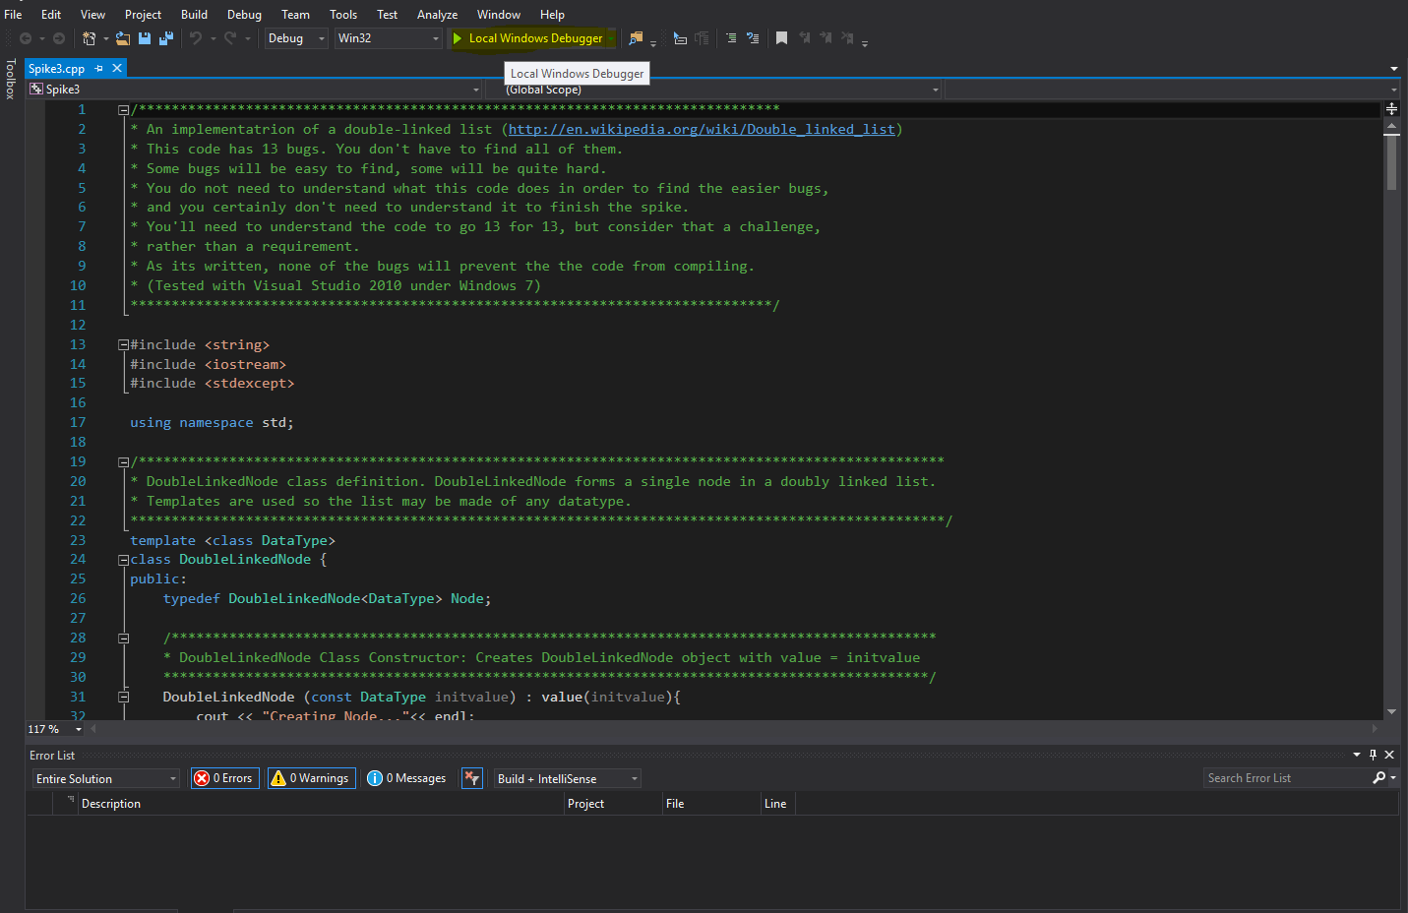

* The program breaks when a bug is discovered. The line will be highlighted. Try to fix the bug. In the below case, L has not been initialized.

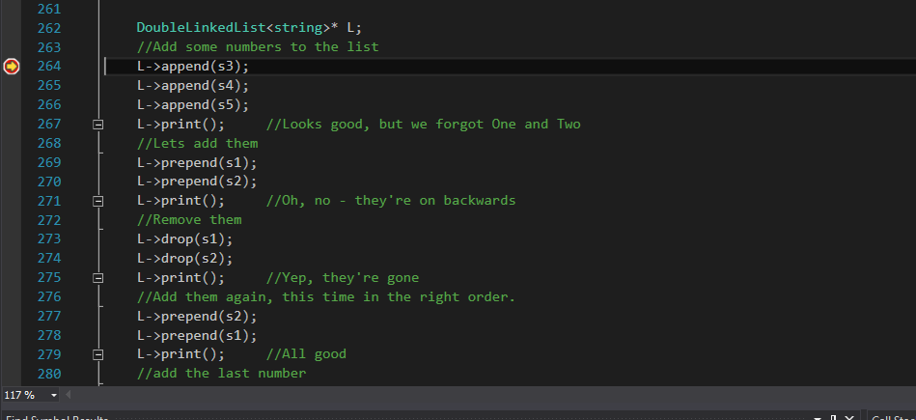

* After fixing the bug, repeat the same process to discover the next bug.
* Repeat the process, until the program is running.
* You might find Step Over functionality really helpful as it shows every line of code that is being executed. You can find out where exactly, the code is breaking. Below is the screenshot.

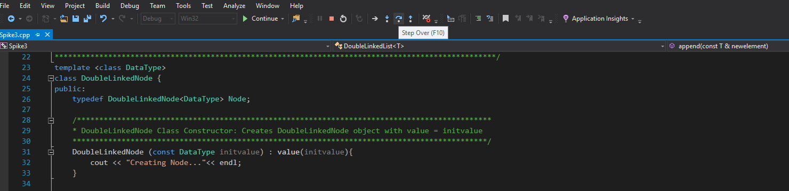

**What we found out:**

After this exercise, I learnt about how double linked lists work. I got the understanding of working with the pointers, lists and nodes. Apart from them, I also enhanced my skills about the debugging tools provided by Visual Studio 2015. I used breakpoints and also used the Step Over functionality a lot to debug. Below is a screenshot of the program running.

